Daniel Chong and Caleb Austin

System Simulation

Project 1

21 February 2021

Analysis

Before running and retrieving our data sets for scenario one and two, Daniel and I first had to come up with an experimental design for both situations. For both situations we decided that it would be best if we ran the simulation multiple times under multiple different arrival rates, so that we would get sound data to represent our final conclusion. The way that we designed our system is exactly how the project asked for it to be designed. We allocated 3 resources (order window, payment window, pickup window) for scenario one, and we allocated 4 resources (order window, order window, payment window, pickup window) for scenario two. Other than the discrepancies in the allotted resource allocation, the two scenarios ran very similarly. Each scenario would run twenty times per tested arrival rate. In our case we tested our system on arrival rates running from 1-20 per 10 time units, so the system was ran four hundred times to ensure that we were receiving good data to utilize later. In each of the two scenarios, we would also keep track of the number of people who were served at the end of test case as well as the number of people who balked (people who arrived but left due to the length of the line). This altogether accounts for our experimental design with which we then ran our system on. The following data demonstrates our findings as well as representations of our data.

**Our Findings**

After running our system, we found that scenario two which utilizes two ordering stations significantly outperforms scenario one which only uses one ordering station. The figure below demonstrates these findings.

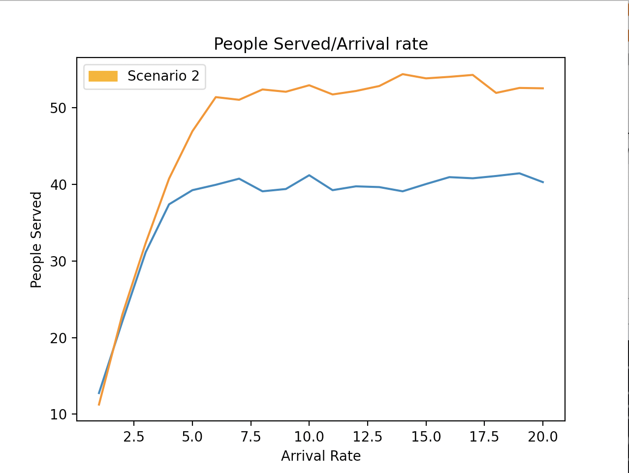

As you can see, the arrival rates ranging from 1-4 prove to be almost insignificant in discrepancies, but once the arrival rate got to 5 and above, the station with two ordering stations started to significantly outperform the station with one ordering station. We found that overall, scenario two served and average of 47.005 customers in total while scenario one served and average of 37.5 customers in total. This shows that on average the scenario with two ordering stations served 9.505 more customers proving that it was more effective.

After conducting our data on the number of people served in both scenarios, we then found how many people balked per arrival rate across both scenarios. This data is displayed in the figure below:

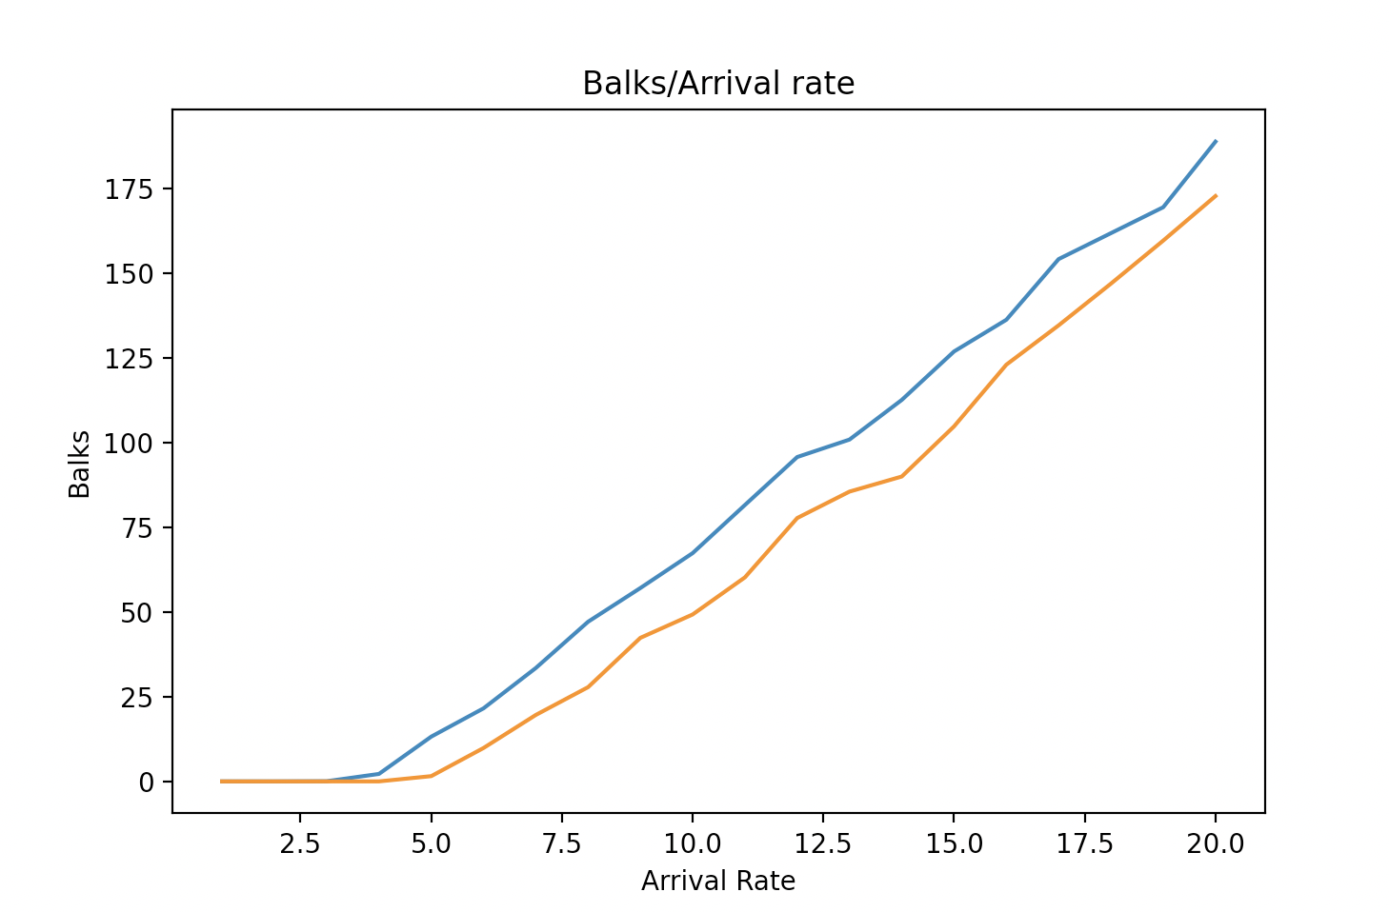

As you can see from the data shown above, we see that as the arrival rate went up the rate of balks went up as well. So both scenarios demonstrated similar patterns, but we see that scenario one had more people balking due to the higher rate of people arriving. Our findings found that on average across all arrival rates in scenario one 80.4 people balked and left the restaurant due to capacity. While scenario two showed us that 66.5 people balked and left the restaurant due to capacity. This shows that scenario one had 13.9 more people balk and leave.

Furthering our data collection, we then sought to find how fast cars got through the whole process from ordering to paying to then receiving their food. Our findings found that the service time for both scenarios was actually very similar. This is demonstrated in the figure below:

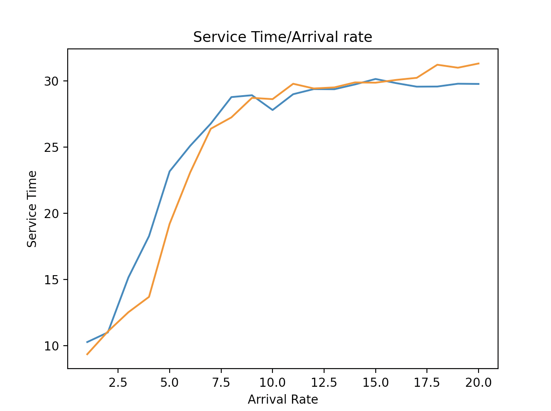

As you can see, the figure shows that as the arrival rate went up the longer it took for cars to finish the whole process. This makes sense because as you start to serve more and more people the kitchen starts to get overwhelmed causing them to move a little slower and ultimately make the entire process longer. What was interesting about this graph was the fact that scenario one and scenario two did not differ a whole lot in service time. This makes sense, though, because the addition of an ordering station does not necessarily affect how quickly the payment window, kitchen, and pickup window move. So we found here that adding an additional ordering window wouldn’t necessarily mean that customers would move through the process faster.

This graph depicts the ratio of balks/services for the various arrival rates. Until about 7.5 customers/10 time units, scenario 1 can maintain a ratio of 1 customer served to 1 customer balked. Until about 10 customers/10 time units, scenario 2 can maintain a ratio of 1 customer served to 1 customer balked. Therefore, scenario 2 can handle more customers without significant bulking.

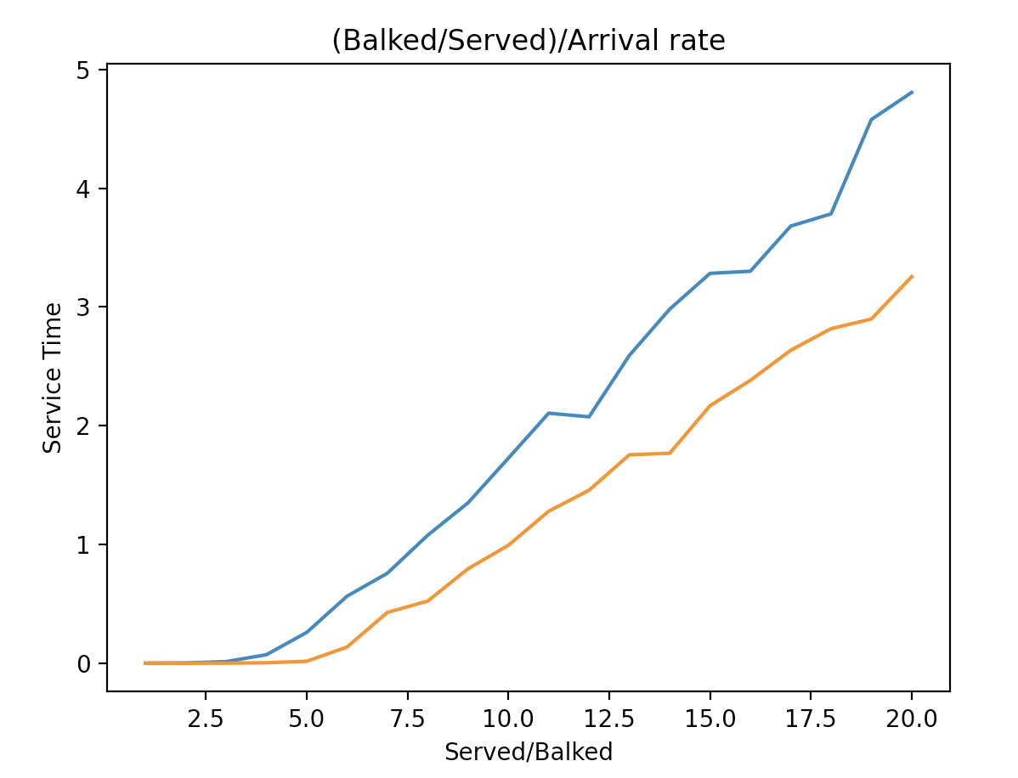

After finalizing, gathering, and inspecting all of our data, we found that it would be most beneficial, if a company had the resources, to add an additional ordering window. This would allow a restaurant to serve more people and have less balks overall. When it comes to the actual scenario our recommendation would be to utilize scenario one with an arrival rate of 7.5 to give the upper limit on customers that can be served without a significant number of people balking. For scenario two we recommend that the user uses an arrival rate of 10 to give the upper limit on customers that can be served without a significant number of people balking.